

_________________________________________________________________________

Charitable Gifting Techniques

© 2016 Greene Consulting Associates, LLC INTENDED SOLELY FOR USE BY REGISTERED USERS NOT TO BE REPRODUCED OR CIRCULATED

ABOUT GREENE CONSULTING ASSOCIATES, LLC
Greene Consulting Associates was founded in 1979 and provides consulting and training services solely to the financial services marketplace. Located in Atlanta, Georgia, Greene Consulting has worked with the top providers of investment management and wealth management in both the United States and abroad. Focused on helping firms generate incremental revenue growth through more effective sales and relationship management strategies, Greene Consulting offers customized training programs in Financial Services Sales, a Sales Management program, Presentation Training that integrates proprietary products, and a comprehensive suite of online learning courses related to investments and wealth management.
For more information about Greene Consulting or any of its products and services, write Greene Consulting at Waterstone Building, 4751 Best Road, Suite 450, Atlanta, GA 30337. Or, visit the company's website at www.greeneconsults.com.

Introduction
The next 50 years will witness an unprecedented transfer of wealth between generations. Estimates of the amount to be transferred go as high as $136 trillion.¹ This presents a great opportunity for many people to take advantage of charitable deductions to save taxes while giving support to charities.
But a survey of 500 financial advisors, accountants, insurance professionals, and attorneys indicated that the most common obstacle clients face when deciding to make charitable gifts is the fear that there will not be sufficient funds remaining to take care of their own needs.² There are solutions that minimize the risk to clients in making lifetime charitable gifts, but that same survey indicated that most financial advisors are limited in their ability to advise clients of these techniques.
Objectives
This module will provide you with the knowledge necessary to suggest viable solutions to clients. At the conclusion of this training module, you will:
- Be familiar with gift and income taxation of charitable gifts.
- Be conversant with various techniques of making lifetime charitable gifts.
- Recognize the variables that affect the size of the donor's income, the amount of the charitable deduction, and the degree of benefit to the charity.
It is important to keep in mind that the purpose of this learning module is not to train you to be a legal or tax expert, but to bring awareness to some of the planning issues and techniques that may be important to the client. Please remember that your role as an advisor must not replace the advice of the client’s legal and tax advisors. As an advisor, you are helping your clients realize the need for proper planning and implement the estate planning strategies by using an array of financial and investment solutions.

¹“Doing Well By Doing Good,” The Philanthropic Initiative, Inc., 2000, p. 23.
² ibid., p. 31.

Tax Benefit of Lifetime Charitable Gifts
One method that results in not paying any estate or gift taxes is to give everything to a qualified charity. Similar to the marital deduction, such transfers escape gift or estate taxation, and there is no limit on the amount or on the percentage of one's estate that may be deducted.
If the gift is made during one's lifetime, there is a potential savings on income taxes as well.
Example. Suppose a client with a taxable estate is thinking of making a charitable gift of $100,000 cash. The client's marginal rate for estate tax purposes is 40% and her income tax marginal rate is 39.6%. Assume the gift is fully deductible for income tax purposes. The client has three potential choices: keep the money, which allows the heirs to inherit it when the client dies; make the gift from the client's estate after death; or make a lifetime gift to the charity. Here are the results of those choices:
Keep the Money |  | Name the Charity  in the Will |  | Make a Lifetime  Charitable Gift
   | $100,000
  Less Estate Tax | (40,000)
  To Heirs | $60,000
   | $100,000
  Less Estate Tax | (0)
  To Charity | $100,000
  Estate Tax*
  Saved: $40,000
   | $100,000
  Less Estate Tax | (0)
  To Charity | $100,000
  Estate Tax Saved: | $40,000
  Income Tax Saved: | $39,600
  Total Tax Savings: | $79,600*
*Note: Depending upon the state, there could potentially be further state tax savings as well.

As the example above shows, making the gift while alive and using the charitable income tax deduction saved an additional $39,600 in income taxes. But unlike the estate and gift tax deduction, which is unlimited, the income tax deduction may be limited. While this can be a complex issue, the following pages will present the most common situations.

Charitable Income Tax Deductions
To obtain a charitable deduction on the Federal Estate, Gift, or Income Tax, a charity must be in the Treasury list of approved tax-exempt charities. This list is available in IRS Publication 78.
Do not confuse non-profit or not-for-profit organizations with tax-exempt organizations. The terms "non-profit" and "not-for-profit" are state law concepts and have nothing to do with the federal tax-exempt status of an organization. An organization must meet specific requirements of the Internal Revenue Code to qualify for tax-exempt status.
There is a limit to how much of a donor's adjusted gross income can be deducted for charitable gifts in a given year. Amounts that exceed that limit can generally be carried forward for five years. This limit is a function of the types of charities involved and the types of property being given.
Types of Charities
Charities can be classified into three types, with public charities receiving the most generous tax treatment.

Public Charities
Public charities are often referred to as 50% limit organizations because donations to them are generally limited to 50% of the donor's adjusted gross income (excluding any net operating loss carry back). They include:
- Churches
- Synagogues
- Colleges
- Universities
- Hospitals
- U.S. Government
- State Government
- Private Operating Foundations
- Private Distributing Foundations
- Private Foundations that Maintain a Common Fund
- Publicly supported corporations, trusts, or community chests, funds, or organizations that exist for charitable, religious, educational, scientific, or literary purposes, or to prevent cruelty to children or animals, or to foster certain amateur sports.

Private Operating Foundations
Private Operating Foundations use most of their income to provide charitable services or to run their own charitable programs. They make little in the way of charitable grants.

Private Distributing Foundations
Private Distributing Foundations are “non-operating foundations,” meaning that they themselves do not provide charitable services. However, they are considered public charities because they distribute 100% of contributions within 2 ½ months following the year they receive the contributions.

Private Foundations that Maintain a Common Fund
These are private foundations that are operated for the benefit of public charities. The funds of contributors are pooled together, with all income distributed to public charities within 2 ½ months following the tax year in which it was realized. They must also distribute the principal not later than 1 year after the donor's death or the death of the surviving spouse, if the spouse can name the recipient.

Semi-Public Charities
- Veterans Organizations
- Fraternal Societies
- Nonprofit Cemeteries
Private Charities
Private Non-operating Foundations that do not meet the distribution requirements to be treated as a public charity.

Income Tax Deductibility of Different Types of Property
There are numerous types of property that can be given to charities, but the most common are listed below. Generally speaking, the amount that can be deducted is either the fair market value (FMV) of the property or its basis (price paid before appreciation). In some cases, it is exclusively one or the other; in other cases, it is the lesser of the two.
The beauty of gifting appreciated property is that the donor pays no tax on the appreciation, yet can receive a charitable deduction for the appreciated amount. While property that has declined in value can be gifted (FMV is less than its basis), this is generally not a good idea because such gifts can only be deducted at the lesser FMV.

Overview | Review this list several times, each time mentally trying to identify the amount prior to clicking each property type.
Cash or Check | FMV
Long-Term Capital Gain Property  (Held for more than a year | FMV or Special Election – Donor can elect to use property’s basis. In exchange, the limit on the percentage of adjusted gross income that can be deducted for the year is raised. This is discussed in more detail on the next page.
Short-Term Capital Gain Property  (Held for a year or less) | Basis
Tangible Personal Property  (Held more than a year) | FMV (if property is used by the charity and is related to its charitable purpose, e.g. art given to a museum)  -or-  Basis (if not to be used by the charity and not related to its charitable purpose)
Life Insurance | Lesser of Cash Value or Basis

Income Tax Deductibility Limits
Depending upon the type of charity and the type of property being contributed, there is a limit to how much can be deducted in any given year. This limit is stated as a percent of the adjusted gross income of the donor (excluding any net operating loss carryback). Any amount that cannot be deducted in a given year can be carried forward (used to reduce your tax liability) over the next 5 years.
These limits are listed below. The maximum cumulative deduction of all types is limited to 50% of adjusted gross income, which is only available for gifts to public charities. When claiming deductions on the income tax return, first priority is given for gifts to public charities. Hence, if a cash gift equivalent to 40% of adjusted gross income was given to a public charity and another cash gift equivalent to 20% of adjusted income was given to a charity that had a 30% limit, the public charity donation would be used first to claim a deduction equal to 40% of adjusted gross income. That would leave only 10% to be used for the other charity, leaving a balance to be carried forward.
In the exercise below, the limits by property type amounts will appear until you click the reset button at the bottom of the list. Review this list several times, each time mentally trying to identify the amount prior to pointing to the arrow. Here's a hint: the 20% limit only comes into the picture for charities that are not public charities.

Property | Amount Deductible |  | Limit Per Year as %  of Adjusted Gross Income
Cash or Check | FMV |  | To Public Charities: 50%  To Other Charities: 30%
Long Term Capital Gain Property  (Held for more than a year) | FMV |  | To Public Charities: 30%  To Other Charities: 20%
Long Term Capital Gain Property  (Held for more than a year) | -or-  Special Election |  | To Public Charities: 50%  To Other Charities: 20%
Short Term Capital Gain Property (Held for a year or less) | Basis |  | To Public Charities: 50%  To Other Charities: 30%
Tangible Personal Property (Held for more than a year) | FMV (for use by charity and related to charitable purpose) |  | To Public Charities: 50%  To Other Charities: 30%
Tangible Personal Property (Held for more than a year) | -or-  Basis (if otherwise) |  | To Public Charities: 50%  To Other Charities: 30%
Life Insurance | Lesser of Cash Value-or-  Basis |  | To Public Charities: 50%  To Other Charities: 30%

Special Election
As shown above, it is possible when gifting long-term capital gain assets to use the basis instead of the fair market value. In return for using the lower amount, the limit on the deduction for public charities is raised from 30% to 50%. This election would most likely be made when there was little or no appreciation and the gift was for more than 30% of the gross adjusted income, thereby enabling the donor to deduct a larger portion of the contribution, although at a lesser valuation.

Gifts of Future Interest
It is possible to take an income tax deduction on gifts that are of a future interest. In other words, the gift is irrevocably made today, but the charity will not receive the asset until some future point in time. These gifts, though, must satisfy certain requirements, as described in the Internal Revenue Code (some of which will be discussed later in this course).
If the gift is for a fixed amount, let's say $100,000, it is certainly worth less to the charity than it would be if the transfer were made today. If the charity received the gift today, it could invest the money and generate additional income. This is income that it forfeits by not receiving the money until some future time.
This is illustrated in the pie diagrams below. In this scenario, assume the current interest rate is 10%. The donor wishes to irrevocably gift $100,000 to a charity. This property is to be held in trust for three years, during which time the donor receives the interest. At the end of three years, the charity is to receive the $100,000. Look at this scenario first from the perspective of the donor; then from the perspective of the charity.
The donor wishes to make a gift of a future interest in $100,000 to a charity. The donor irrevocably gifts the $100,000 today, but for three years he retains the interest earned on the money. At the end of the three years the charity receives the $100,000 outright. Assume that the current interest rate is 10%.

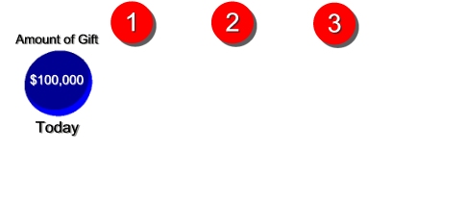

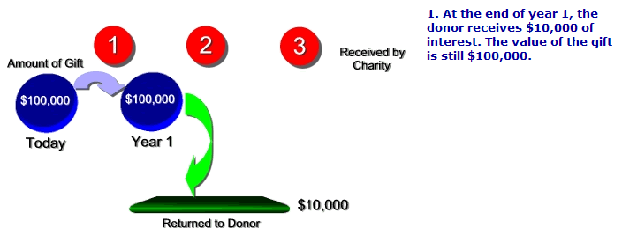

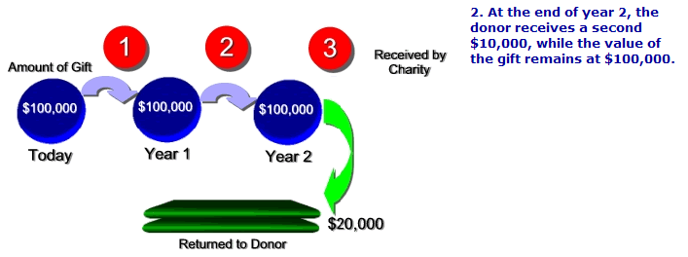

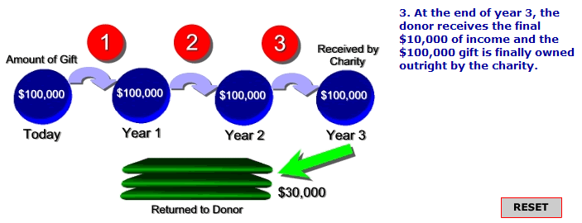

From the donor's perspective, he initially gifts $100,000 and the value of the gift never changes until the charity receives it. He would like to claim a $100,000 income tax deduction. But was the present value of his gift really worth $100,000? To answer that question, let's look at it from the charity's perspective. We will start with the end of the third year when the charity receives the $100,000 and work our way backward to determine what amount would provide the same benefit to the charity if it were given outright to the charity today instead of in three years. We will assume that the charity could earn 10% each year on the preceding balance.
Let's start with the end of the third year when the charity is to receive the $100,000 and work our way backward to determine what amount would provide the same benefit to the charity if it were given outright to the charity today instead of in three years. We will assume that 10% could be earned each year on the money.



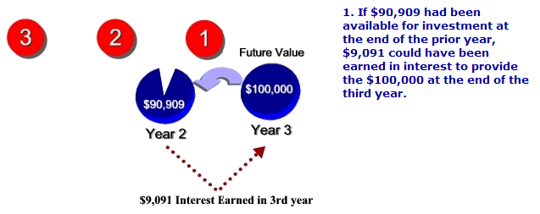

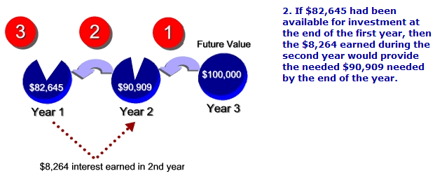

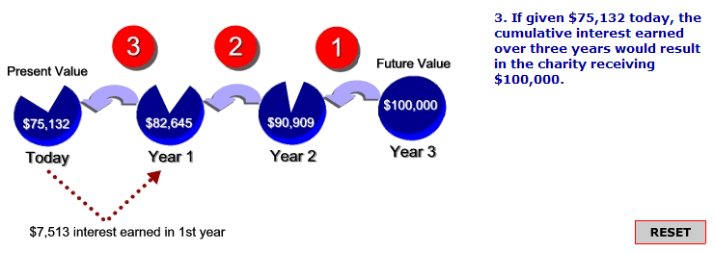

The scenario from the charity's perspective is essentially a present value calculation-deriving what present amount is equal to a future amount. With an interest rate of 10%, $75,132 given today is equal to $100,000 given three years from now. This $75,132 is precisely the value of the donor's gift today because the donor retained the right to the income and the charity did not receive the gift for three years. The IRS views this scenario in the same way, and provides discount tables to determine the present value that can be deducted when a gift of a future interest is made. The IRS sets the interest rate (discount rate) that is used in the tables, but allows for such variables as the amount of the annual distribution to the donor and the time horizon before the charity receives the gift.
To gain more insight into how these variables can alter the present value and the value of the charitable deduction, refer to the scenario above and answer the following questions.

- If the donor wanted to receive $12,000 per year, taking first from income and then from the corpus, would the present value of the gift to the charity increase or decrease?
Decrease The greater the amount being received by the donor, the less the value of the gift to the charity. This is because the donor is not only taking out all the income, but some of the corpus as well.
- If the donor wanted to receive $6,000 per year, would the present value of the gift to the charity increase or decrease ?
Increase The less the amount being received by the donor, the greater the value of the gift to the charity. In this example, the donor's decision to receive a smaller annual amount means that more value will pass to the charity.
- If the donor maintained the demand for $10,000 per year, but decided to extend the time before the charity received the gift from 3 years to 6 years, would the present value of the gift to the charity increase or decrease ?
Decrease. The longer the deferral period, the less the present value of the gift to the charity. This is because the charity is forfeiting more years in which it could be retaining the earnings.

Review Exercise
To review the concepts that have been presented thus far, answer the following questions.
For the following statements, indicate if the statement is true or false:
- Charitable gifts are always 100% deductible on income tax returns.
- True
- False
- The designations "tax-exempt charity" and "not-for-profit" are one and the same.
- True
- False
- Some gifts to private foundations are treated the same as public charities when computing the income tax deductibility of gifts.
- True
- False
- Deductions on long-term capital gain property are always limited to 30% of adjusted gross income if gifting to public charities.
- True
- False

Identify each property type as either Deductible or Not Deductible at FMV.

Type of Property | Deductible at FMV |  | Not Deductible at FMV
A stamp collection given to the Salvation Army
Short-Term Capital Gain Property
Long-Term Capital Gain Property
A painting given to a museum for display
Cash
The answers to these questions are found on the following page.

Review Exercise – Answer Key
To review the concepts that have been presented thus far, answer the following questions.
For the following statements, indicate if the statement is true or false:
- Charitable gifts are always 100% deductible on income tax returns.
- True
Incorrect. They are limited to a percentage of adjustable gross income (excluding any net operating loss carryback).
- False
Correct. They are limited to a percentage of adjustable gross income (excluding any net operating loss carryback).
- The designations "tax-exempt charity" and "not-for-profit" are one and the same.
- True
Incorrect. The term "not-for-profit" is a designation that is granted under state law; it is not the same as a "tax-exempt charity" as recognized by the IRS.
- False
Correct. The term "not-for-profit" is a designation that is granted under state law; it is not the same as a "tax-exempt charity" as recognized by the IRS.
- Some gifts to private foundations are treated the same as public charities when computing the income tax deductibility of gifts.
- True
Correct. Certain private foundations, such as private operating foundations, are treated as public charities.
- False
Incorrect. Certain private foundations, such as private operating foundations, are treated as public charities.
- Deductions on long-term capital gain property are always limited to 30% of adjusted gross income if gifting to public charities.
- True
Incorrect. A special election can be made that allows you to deduct up to 50% of adjusted gross income. However, the deduction must then be based on the lesser of the tax basis or FMV rather than just the FMV.
- False
Correct.

Identify each property type as either Deductible or Not Deductible at FMV.

Type of Property | Deductible at FMV |  | Not Deductible at FMV
A stamp collection given to the Salvation Army |  |  | X
Short-Term Capital Gain Property |  |  | X
Long-Term Capital Gain Property | X
A painting given to a museum for display | X
Cash | X
Correct.
Incorrect.

Charitable Remainder Trusts
The preceding scenario illustrates what is called a charitable remainder trust. Charitable remainder trusts can be created during one’s lifetime or upon death through one’s will. In this course, we will focus on those created during life.
Here is how a charitable remainder trust works:
The IRS has issued sample trusts that serve to guide attorneys in drafting charitable remainder trusts that will qualify for the income tax charitable deduction. These trusts are characterized by the following:
- The trust can provide income for one or more beneficiaries. Generally, only the grantor or the grantor and his/her spouse are named as the income beneficiaries, so as to avoid transfer tax issues associated with naming anyone else, but other beneficiaries are possible.
- The trust can be written to terminate upon the death of the income beneficiary or upon their combined deaths if more than one. Alternatively, the trust can be written to terminate at the end of a specific number of years, not to exceed 20 years; or it can be written to run until the death of the income beneficiaries with a term certain of up to 20 years.
- While the trust is irrevocable, the charitable beneficiary designation can be changed without losing the tax advantages of the trust.
- The annual payout to the income beneficiary(ies) cannot be less than 5% or more than 50% of the value of the trust. This amount must be paid at least annually to the noncharitable income beneficiary out of the income and/or principal of the trust.

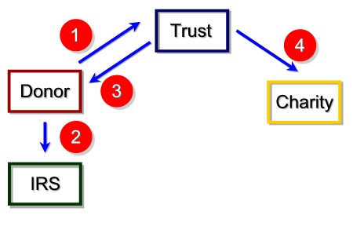
1
While the donor can technically fund the trust with any type of property, it is generally not advisable to use property that has declined in value from its purchase price, as such assets will be valued at their current market value and the possibility of using the loss to offset income taxes will be lost. Generally speaking, appreciated property should be given first priority. This is because no capital gain taxes are payable when the property is donated. If the trust later sells the asset, again there are no capital gain taxes. Only if the capital gain gets paid out to the income beneficiary would the beneficiary be subject to the tax.
Note that the remainder interest must have an actuarial value that is at least 10% of the initial value of the property contributed to the trust. Anything less will prevent the trust from qualifying as a charitable remainder trust.

2
The donor gets an immediate Federal income tax deduction. The tables that are used to calculate the amount that may be deducted will take into account the number of years before termination of the trust and distributions of income to the donor. If the trust is for the lifetime of the income beneficiary(ies), the tables will also take into consideration life expectancy.

3
When the income beneficiary receives the required distributions, the income taxes assessed to that distribution are determined using a tiering methodology. This income is paid out and taxed on a four tier system, in order:
- Ordinary income
- Capital gain income
- Tax-exempt income
- Tax-free distributions of principal
Income at the trust level is allocated for accounting purposes to the appropriate tier. The taxation of each distribution is determined by first applying the Tier 1 accounting allocation until exhausted, then tier 2 until exhausted, and so on. For example, suppose a trust must make a distribution to the beneficiary of $6,000 and has accumulated income as follows:
Tier 1: Ordinary income: $5,000
Tier 2: Capital gain income: $3,000
Tier 3: Tax-exempt income: $1,000
When the distribution is made, it would be made up of $5,000 of ordinary income and $1,000 of capital gain income. If, however, the distribution had been for $10,000, then the distribution would include $5,000 of ordinary income, $3,000 of capital gain income, $1,000 of tax-exempt income, and $1,000 of principal.
Keep in mind that the trust assumes the donor's cost basis in the property/asset contributed. Thus, if the contributed property is subsequently sold by the trust, the income realized as a result of the sale is allocated to the appropriate tier to be applied against future distributions. Though any gain on the contributed property is avoided by the grantor, it is likely to be in turn taxed to the income beneficiary as distributions are received. Thus, if the grantor is also a beneficiary, the gain may not be ultimately avoided.

4
Upon termination, the charity receives the corpus of the trust. This amount may be more or less than was originally contributed, depending upon investment performance and the degree to which income was allowed to accumulate and principal was not encroached.

Two Types of Charitable Remainder Trusts
Generally speaking, charitable remainder trusts are classified into two types, depending upon how the income distributions are computed. In each case, the trust document will provide a stated percentage that is to be applied against the fair market value (FMV) of the account. This percentage must be between 5 % and 50%. What distinguishes the two types is when the calculation is made.
Charitable Remainder Annuity Trust (CRAT)
The calculation is made one time only, against the initial FMV of the account. This results in a fixed distribution each year.
Charitable Remainder Unitrust (CRUT)
The calculation is made annually, against the current FMV of the account.
Both are typically referred to by pronouncing their initials as if they formed words. The fact that the calculations are computed differently results in some different features that might make one or the other more appropriate for a given situation. These features are compared in the chart below.
To reinforce learning, try to answer each of the following questions for yourself.
 |  | Charitable Remainder Annuity Trust (CRAT) | Charitable Remainder Unitrust (CRUT)
When is the income calculation made?
Does the income distribution vary?
Does it provide some protection against inflation?
Does it provide a fixed distribution amount?
Can further contributions be made to the trust?
As can be seen in the chart, the CRAT might appeal more to someone who wants the certainty of a fixed annual income distribution. The CRUT might appeal more to someone who is comfortable having their income stream be subject to market risk.
The answers to these questions are found on the following page.

Two Types of Charitable Remainder Trusts – Answer Key
To reinforce learning, try to answer each of the following questions for yourself.
 |  | Charitable Remainder Annuity Trust (CRAT) | Charitable Remainder Unitrust (CRUT)
When is the income calculation made? |  | Once, using the initial FMV | Annually, against the FMV each year
Does the income distribution vary? |  | No. It is a fixed annual payout | Yes. It varies as the FMV changes each year.
Does it provide some protection against inflation? |  | No | Yes. The market value should rise with inflation, raising the income distribution as well.
Does it provide a fixed distribution amount? |  | Yes | No. The distribution will vary with changes to the trust’s market value
Can further contributions be made to the trust? |  | No. There is no way to recompute the income distributions. | Yes, the additions would simply be included in the annual FMV calculations.
As can be seen in the chart, the CRAT might appeal more to someone who wants the certainty of a fixed annual income distribution. The CRUT might appeal more to someone who is comfortable having their income stream be subject to market risk.

Two Variations on the Charitable Remainder Unitrust
One of the great appeals of charitable remainder trusts is the income stream that the income beneficiaries receive. To a large degree, this income stream is protected because principal can be used to make up any deficiencies. But there are times when the donor places greater emphasis on preserving the principal, and wants to prevent encroachments.
Because the payout of a CRAT is fixed at the beginning, it is not possible to adjust the annual payout so as to prevent encroachments of principal. But with unitrusts it is possible to adjust the payout each year, therefore unitrusts are often drafted in ways that allow the adjustment to prevent encroachment of principal. This is accomplished using one of the following techniques.
Net Income Charitable Remainder Unitrust (NICRUT)
A unitrust that pays the lesser of the unitrust amount or the actual net income. If net income is insufficient to reach the unitrust amount, then no encroachment of principal is made to make up the difference.
Net income with Make-Up Charitable Remainder Unitrust (NIMCRUT)
Just like the NICRUT, the payout is the lesser of the unitrust amount or net income. However, if net income is insufficient to pay the unitrust amount, the deficiency is carried over to subsequent years and would be covered if there were years with an income surplus.
These trusts can be more appealing to younger persons who have no immediate need for income. The trustee can adjust the portfolio to maximize growth during the years when income is not needed, and readjust to generate higher income when it is. However, NICRUTs or NIMCRUTs do have a unique risk in that if the income beneficiary dies during the non-income paying term of the trust, that income is lost to the family forever, since the trust will become payable to the charity.

Using a Charitable Remainder Trust
Charitable trusts take some of the risk out of making lifetime gifts for persons who are concerned about loss of income. In fact, they can be particularly advantageous in certain circumstances.
Highly Appreciated or Low Income Producing Property
The greatest benefit to utilizing a charitable remainder trust is when you are dealing with highly appreciated long-term capital gain property and/or property that provides a very low income. Both of these factors are illustrated in the following scenario.

Mrs. Thurmond’s Situation
Mrs. Thurmond was given 100 shares of ABC Company on her 18th birthday. That was 60 years ago! Affected by the Great Depression, this is the only stock she has ever owned. It has split eight times since she received it, now giving her 25,600 shares with a market value of approximately $1,000,000. Her basis is only pennies per share.
Her estate is worth $8 million, some of which is land that she plans to pass on to her children. And her current income is $200,000 per year, of which ABC stock provides $20,000. Her arthritis is requiring her to have some live-in assistance, and she needs to generate an additional $50,000 of income to cover all expenses. She would not be opposed to selling the ABC stock, but does not want to pay the tax bill that will generate.
Her will states her intent to give a substantial portion of her estate to charity, but she has been rather hesitant to give much during her lifetime out of fear of not having enough to meet her needs.
Solution
Mrs. Thurmond creates a charitable remainder annuity trust with a 7% payout. She pays no capital gains tax when making the contribution (although she may have to pay some capital gains taxes in future years if the trust passes gains out to her to meet the 7% payout obligation). The trust can then sell the security, diversify the portfolio and distribute $70,000 per year to her. After taxes, this should provide Mrs. Thurmond with the income she needs. She will also have the added income tax benefit of the charitable deduction. More important, she has met both her income need and fulfilled her charitable intent.

Use of an Irrevocable Life Insurance Trust with a CRT
One of the obstacles to creating a charitable remainder trust is that making the charitable gift requires diminishing the estate that would otherwise pass to the donor's heirs. This can often be overcome by combining the Charitable Remainder Trust with an Irrevocable Life Insurance Trust (often called a Wealth Replacement Trust). In this way the donor can accomplish all of the following:
- Reduce or totally eliminate the estate tax.
- Receive an immediate income tax charitable deduction.
- Maintain or even increase income.
- Support a favorite charity.
- Preserve the size of the estate that is passed on to the donor's heirs.
The diagram below illustrates how this works. Part of the diagram is already familiar to you from the earlier presentation of the charitable remainder trust. The only thing new is the introduction of the Irrevocable Life Insurance Trust into the plan.
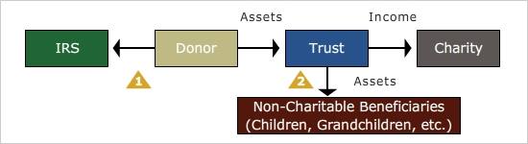

1
The donor creates an irrevocable life insurance trust, then contributes to it part of the income he receives from the charitable remainder trust. The irrevocable life insurance trust uses those contributions to purchase life insurance in an amount that will replace assets placed in the charitable trust. Since the trust is the initial owner of the policy, the insurance proceeds upon the insured’s death will not be subject to estate tax. (In comparison, if the donor funds the trust with a pre-existing policy on his/her life, then the proceeds escape estate taxation only if the donor lives for at least 3 years after the transfer, as transfers of life insurance within 3 years of death are included in the transferor’s estate.)

2
When the donor dies, the beneficiaries receive the life insurance proceeds, and the charity receives the remainder of the trust assets.

Pooled Income Fund
Not everyone can make gifts that are sizeable enough to warrant the expense of setting up and managing a trust. That is why many charitable institutions have established their own pooled income funds. Similar to making contributions to a charitable remainder trust, donors who make contributions into a pooled income fund do not pay capital gain on appreciated property, receive recurring income in exchange for their gift, and get an immediate income tax deduction. The amount of that deduction, as with charitable remainder trusts, is the present value of the remainder interest that will go to the charity. Upon their death, the charity receives the principal.
These funds operate much like participation in a mutual fund. Contributions of various donors are pooled together and contributors receive participation units based on the value of their contribution relative to the whole. Income is then received based upon the number of units owned and the investment return of the fund. Although these funds can establish many of their own guidelines, the Internal Revenue Code provides many guidelines that must be observed if a charitable deduction is to be available.

Charitable Lead Trust
Thus far, the gifting techniques presented have made the donor or some other person the income beneficiary, and the charity the remainder beneficiary. But it is possible to do exactly the reverse through a charitable lead trust. In this case, the charity enjoys the income from the property for a period of time, and distributes the property to the beneficiary(ies) when the trust terminates.
The following features are found in the trust document of a charitable lead trust:
- Similar to a charitable remainder trust, a charitable lead trust may be structured to pay income either as a charitable lead annuity trust (CLAT) or charitable lead unitrust (CLUT). However, they are typically structured as annuity trusts to keep the valuation simple.
- The trust may last for the lifetime of the donor or another individual named by the donor, or for a specific number of years. Unlike a CRT, there is no limit to 20 years if a specific number of years is chosen.
- For the donor to receive an immediate income tax deduction for making the gift, the charity's interest must be guaranteed by the document and the donor must be taxed on the income generated by the trust. If these conditions are met, the donor receives an immediate income tax deduction for the present value of the future income stream that will go to the charity; then, each year, the donor will be taxed on the trust income with no offsetting charitable deduction.
- Unlike a CRT, no minimum payout is required.

1
A taxable gift may be involved in assigning the remainder interest of the trust assets. The gift tax would be based on the present value of the remainder beneficiaries' right to receive the assets at some future time. Calculation of the tax depends upon the duration of the trust, the payout amount, and the rate used in the IRS tables. But due to the discounting that is derived from giving the charity years of income off the assets, considerable discounting can take place resulting in significant savings over transferring the assets directly to the remainder beneficiaries.

2
Upon the termination of the trust, the remainder beneficiaries receive assets from the trust. Since any transfer taxes were taken into consideration when the trust was funded, this transfer then takes place with no additional gift or estate taxes. This is quite significant, indicating that any appreciation in the market value of the assets within the trust will transfer to the beneficiary(ies) free of gift or estate taxes.
The charitable lead trust is an excellent way to support charities while reducing the gift taxes on the portion that will go to remainder beneficiaries. For example, with an IRS required discount rate of 2.0% (the rate in January 2016), a $1,000,000 contribution to a 10-year CLAT, paying 7% annually (as valued when the trust was funded) to a charity, will result in a present value calculation of $628,782 as the value of the annuity going to the charity, and the balance of $371,218 as the present value of the gift that will ultimately go to the remainder beneficiaries.
If the trust is instead structured as a 15-year CLAT, then the present value of the gift to the charity increases to $899,451 and the value of the gift to the remainder beneficiaries decreases to $100,549. Structure it as an 17-year CLAT, and the present value of the gift to the remainder beneficiaries declines to zero.
This technique can result in substantial estate and gift tax savings for affluent clients, and are especially powerful when the IRS Discount rate is low. The reason for this is that a low discount rate maximizes the present value of the income stream going to the charity, which in turn lessens the present value of the gift being made to the remainder beneficiaries.

Review Exercise
Answer the following questions.
- Increasing the interest rate used to compute the annual income payout of a CRAT would decrease the charitable deduction when funding the trust.
- True
- False
- The actuarial value of the remainder interest of a CRT must be at least ___% of the initial value of the trust.
- 5%
- 10%
- 20%
- 30%
- 60%
- A CRT can terminate upon the death of one or more people, or it can be setup to exist for a specific number of years up to:
- 5 years
- 10 years
- 15 years
- 20 years
- 30 years
- The annual payout of a charitable remainder trust to the income beneficiaries cannot be less than 5% or more than _____.
- 10%
- 15%
- 20%
- 25%
- 50%
- After paying out ordinary income, the next tier of payout in a CRT income distribution comes from accumulated:
- Tax-exempt income
- Principal
- Capital Gain Income
- Of the CRAT and CRUT, the CRAT is the one with an income distribution that varies.
- True
- False
- Some level of protection against market value fluctuations is provided by a CRAT.
- True
- False
- Pooled Income Funds are generally established by:
- Young grantors
- Older grantors
- Beneficiaries
- Charities
- Testamentary Trusts
- The duration of a Charitable Lead Trust is either the lifetime of the donor or another individual named by the donor, or for a specific number of years up to:
- 10 years
- 15 years
- 20 years
- Any number of years
- The minimum payout requirement of a Charitable Lead Trust is:
- 3%
- 5%
- 10%
- 15%
- Nonexistent (there is no minimum)
The answers to these questions are found on the following page.

Review Exercise - Answer Key
Answer the following questions.
- Increasing the interest rate used to compute the annual income payout of a CRAT would decrease the charitable deduction when funding the trust.
- True
Correct.
- False
Incorrect.
- The actuarial value of the remainder interest of a CRT must be at least ___% of the initial value of the trust.
- 5%
Incorrect.
- 10%
Correct.
- 20%
Incorrect.
- 30%
Incorrect.
- 60%
Incorrect.
- A CRT can terminate upon the death of one or more people, or it can be setup to exist for a specific number of years up to:
- 5 years
Incorrect.
- 10 years
Incorrect.
- 15 years
Incorrect.
- 20 years
Correct.
- 30 years
Incorrect.
- The annual payout of a charitable remainder trust to the income beneficiaries cannot be less than 5% or more than _____.
- 10%
Incorrect.
- 15%
Incorrect.
- 20%
Incorrect.
- 25%
Incorrect.
- 50%
Correct.
- After paying out ordinary income, the next tier of payout in a CRT income distribution comes from accumulated:
- Tax-exempt income
Incorrect.
- Principal
Incorrect.
- Capital Gain Income
Correct.
- Of the CRAT and CRUT, the CRAT is the one with an income distribution that varies.
- True
Incorrect.
- False
Correct.
- Some level of protection against market value fluctuations is provided by a CRAT.
- True
Correct.
- False
Incorrect.
- Pooled Income Funds are generally established by:
- Young grantors
Incorrect.
- Older grantors
Incorrect.
- Beneficiaries
Incorrect.
- Charities
Correct.
- Testamentary Trusts
Incorrect.
- The duration of a Charitable Lead Trust is either the lifetime of the donor or another individual named by the donor, or for a specific number of years up to:
- 10 years
Incorrect.
- 15 years
Incorrect.
- 20 years
Incorrect.
- Any number of years
Correct.
- The minimum payout requirement of a Charitable Lead Trust is:
- 3%
Incorrect.
- 5%
Incorrect.
- 10%
Incorrect.
- 15%
Incorrect.
- Nonexistent (there is no minimum)
Correct.

Conclusion
This concludes the material for this subject. At this time you may return to any sections in which you feel the need for further study.

